The Rt Hon Michael Gove MP
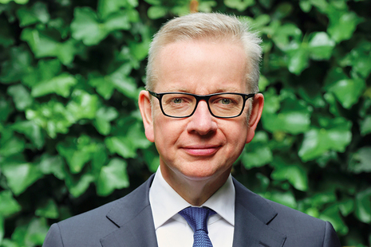

Biography
The Rt Hon Michael Gove was appointed Secretary of State for Levelling Up, Housing and Communities on 15 September 2021.
He was previously Chancellor of the Duchy of Lancaster from July 2019 to September 2021. He was also Minister for the Cabinet Office from February 2020 to September 2021. He was Secretary of State for Environment, Food and Rural Affairs from June 2017 to July 2019. He was elected Conservative MP for Surrey Heath in 2005.

Education
Michael was educated at Robert Gordon’s College, Aberdeen and Lady Margaret Hall, Oxford University.
Political career
Michael was Shadow Minister for Housing from 2005 to 2007 and Shadow Secretary of State for Children, Schools and Families from 2007 to 2010.
He served as Secretary of State for Education from May 2010 until July 2014. From July 2014 to May 2015, he served as Government Chief Whip and Parliamentary Secretary to the Treasury. Michael also served as Lord Chancellor and Secretary of State for Justice from May 2015 until 14 July 2016.

Career outside politics
Michael became a journalist after leaving university, working as a reporter for The Press and Journal in Aberdeen, a researcher and reporter at Scottish Television and a reporter for BBC Television. He was later Assistant Editor of The Times.

